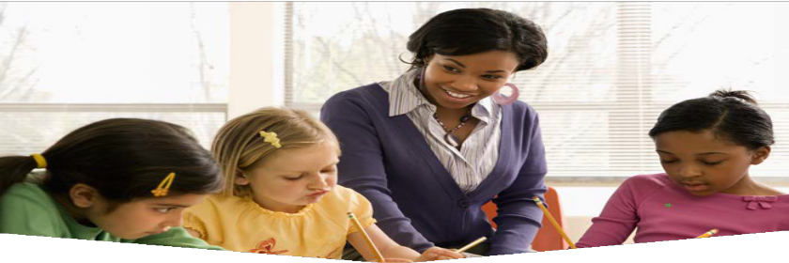
MAKE YOUR CHILD CARE
BREASTFEEDING FRENDLY!

SUPPORT FAMILIES WHO ARE BREASTFEEDING

Remove this framed box and add your own image here. Or use the original image behind this box.

Why should becoming a breastfeeding friendly child care matter to your program?
Attracts and retains customers (less turnover) Exemplifies that your child care is a leader in health promotion
50% fewer sick days for mom and baby
(breastfed babies are healthier)
Receive a certificate to display
Recognition on the MDH website

What does it mean to be a breastfeeding friendly child care program?
There is a supportive culture from all staff surrounding breastfeeding
Have a lactation space (cannot be a bathroom)
Have a lactation policy or guidelines in handbook

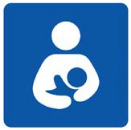IS YOUR CHILD CARE READY?
The (your breastfeeding coalition name here) may be able to support your initiative with technical assistance and potential funding to create the space.
Contact us at:
Did you know? Providing time and space for pumping is the law. To learn more, search online: “Breastfeeding laws: federal and state”

Take it a step further to become a MN Department of Health Breastfeeding Friendly Child Care

Implement these steps:
Policy: Develop a written policy or guideline that is routinely shared with staff and addresses the elements of support, time and space outlined below.
Support: Post encouraging messaging in the lactation space and share specific breastfeeding resources in your community Time: Give employees time to pump/express
milk
Space: Dedicate an area to privately express milk (including a locked door and electrical outlet)

Apply at:
https://www.health.state.mn.us/people/
breastfeeding/recognition/childcare.html

Your logo here

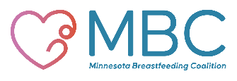

Content designed by Dakota County Public Health Department 10/19

