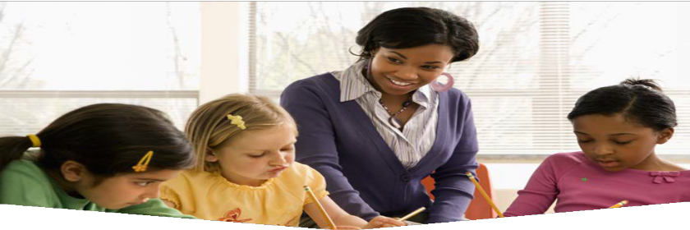
MAKE YOUR SCHOOL A
BREASTFEEDING FRENDLY
WORKPLACE!

SUPPORT STAFF WHO ARE BREASTFEEDING

Remove this framed box and add your own image here. Or use the original image behind this box.

Why should becoming a breastfeeding friendly workplace matter to your school?
Attracts and retains employees (less turnover) Exemplifies that your school is a leader in health promotion
50% fewer sick days for mom and baby
(breastfed babies are healthier)
Lactation support improves employee productivity Lowers health care and insurance costs
(up to $500 reduction in healthcare costs per child)

What does it mean to be a breastfeeding friendly workplace?
There is a supportive culture from supervisors surrounding breastfeeding
Have a lactation space (cannot be a bathroom) Allow solutions in daily scheduling for adequate time for pumping

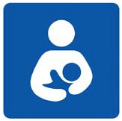IS YOUR SCHOOL READY?
The (your breastfeeding coalition name here) may be able to support your initiative with technical assistance and potential funding to create the space.
Contact us at:
Did you know? Providing time and space for pumping is the law. To learn more, search online: “Breastfeeding laws: federal and state”

Take it a step further to become a MN Department of Health Breastfeeding Friendly Workplace

Implement these steps:
Policy: Develop a written policy or guideline that is routinely shared with staff and addresses the elements of support, time and space outlined below.
Support: Post encouraging messaging in the lactation space and share specific breastfeeding resources in your community Time: Give employees time to pump/express
milk
Space: Dedicate an area to privately express milk (including a locked door and electrical outlet)

Apply at:
https://www.health.state.mn.us/people/ breastfeeding/workplaces.html

Your logo here

Content designed by Dakota County Public Health Department 10/19

