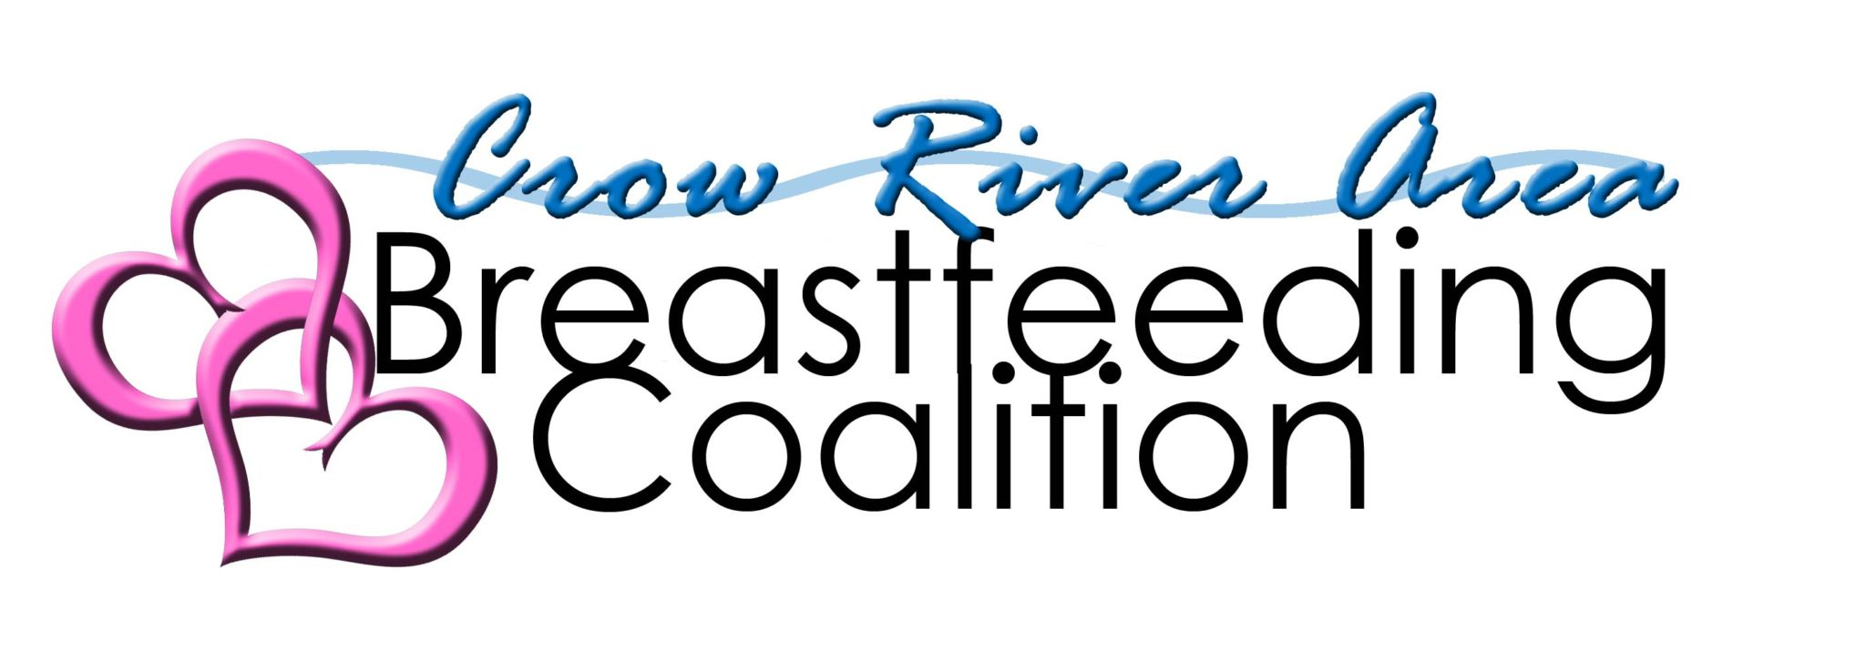

Supporting breastfeeding families in Meeker, McLeod & Sibley Counties

Dear Employer, Date: ___________

I’m like many moms…. When I return to work, I plan to continue to feed my baby breastmilk and need time and space to pump.

I look forward to your support to provide my child the best nutrition possible. As you may know, Minnesota laws provide protection for working moms who need time and space to pump.

Thank you!

Signed,

___________________

